Diploma Pre-Defense 1
“Development of a Digital Platform to Support Admission to Higher Education Programs”

Team: Medeubek Dinara, Jaxygaliyev Artur
Supervisor: Altynbek Seitenov

GitHub repository: https://github.com/Arthurmyn/unified-applicant-platform
YouTrack project: https://udp.youtrack.cloud/dashboard?id=177-0

1.Project Proposal

Item | Value
Project title | Development of a Digital Platform to Support Admission to Higher Education Programs
Team members | Medeubek Dinara, Jaxygaliyev Artur
Supervisor | Altynbek Seitenov
Programme | Software engineering, Astana IT University

1.1 Problem Statement
Applicants to Bachelor's, Master’s, Doctoral programs have to collect information from different sources, such as university websites, national testing organization, scholarship portal like Bolashak through eGov.kz, language providers, and informal sources. The requirements vary depending on the country, university, degree, and admission pathway, and they can change overtime. As a result, applicants face information overload and often struggle to find all the information they need in one place [3]. Global rankings also fail to account for individual preferences and needs [4], while most academic recommender systems have been tested in laboratory settings rather than in real-world conditions [2].
The main problem is that applicants cannot easily check whether they meet a program’s requirements, identify what they are missing, or understand what steps to take next and when to complete them. This happens because the information is spread across different sources, requirements change over time, and it is often unclear whether the information is still valid or has been verified.

1.2 Target User

User Group | Role in the MVP
Applicants to Master’s programmes in Kazakhstan and Abroad | Included: Primary users, profile, AI-assisted onboarding, gap analysis, personalized roadmap
Bachelor’s Programmes | Included: Primary users, profile, AI-assisted onboarding, gap analysis, personalized roadmap
Doctoral / PhD programmes | Included: Primary users, profile, AI-assisted onboarding, gap analysis, personalized roadmap
Teachers, Mentors and Supervisors | Excluded: Future Extension
Administrations | Included: the project team manages and verifies data

1.3 Aim
To design, develop, and evaluate a digital platform to Bachelor’s, Master’s, Doctoral/PhD programmes in Kazakhstan and Abroad by transforming their academic profile and study goals - into a verified, explainable and actionable admission pathway. The MVP provides programme discovery, eligibility and gap analysis, personalized roadmap, deadline tracking, and source-grounded AI-guidance.

1.4 Objectives

ID | Objectives
O1 | Analyze the needs and admission workflows of applicants to Bachelor’s, Master’s, and Doctoral/PhD programmes in Kazakhstan and the United States, using interviews and official sources.
O2 | Design and Populate a database of at least 20 programmes in Kazakhstan and the the United States, including degree levels, requirements, deadlines, documents, official URLs, verification dates and statuses.
O3 | Implement a Russian-language AI-assisted onboarding flow that creates an editable profile with education, GPA, field, target degree and country, intake, budget, language, scores, citizenship and document readiness. The design shall support future Kazakhs and English localization.
O4 | Implement rule-based eligibility matching and gap analysis for GPA, degree background, language scores, examinations, deadlines documents, budget, citizenship and work experience. Each requirement shall be classified as Meets, Action needed or Unknown, with an explanation.
O5 | Create a personalised admission and training plan based on gaps, proven deadlines, and task dependencies. Candidates can mark tasks as completed, while administrators keep track of program deadlines.
O6 | Develop a source-grounded AI advisor that answers questions using only verified programme databases, cites official sources, and declines to answer when verified information is unavailable.
O7 | Implement an administration interface for managing users, universities, programmes, requirements, deadlines, sources, and verification statuses, including alerts for missing outdated, or conflicting records.
O8 | Evaluate the MVP prototype using pilot data, synthetic applicant profiles, and user testing. Assess requirement accuracy, AI grounding, gap-analysis quality, task completion, usability and response time.

1.5 Expected Outcomes

ID | Outcome
D1 | A functional MVP that integrates all the main features described in section 1.6
D2 | A pilot dataset containing 20 verified programmes across Bachelor’s, Master’s and doctoral/PhD levels, supported by official sources and verification dates.
D3 | Technical documentation covering system requirements, architecture, schematics, and technology selection.
D4 | A report on evaluating the effectiveness of the platform in accordance with the basic criteria set out in section 9.

1.6 Project Slope
Following the supervisor’s recommendation, the project scope has been revised to distinguish essential MVP features from those that can be developed later.

The Platform is intended for applicants applying to higher-education programmes in Kazakhstan and abroad. The MVP will demonstrate this wider purpose using a pilot dataset of 20 selected programmes across these degree levels. This smaller dataset limits the initial data collection and evaluation, but it does not limit the platform’s intended audience. The proposed change from approved by the supervisors before it becomes a confirmed requirement.

Category | Features | Priority
Core | Applicant profiles and AI-assisted onboarding. University and programme information with verified admission requirements. Eligibility matching and gap analysis. Personalised application roadmaps. An AI advisor that uses verified sources and administrator workflow for verifying information. | Must
Supporting features | Application checklist, deadline tracking, and email reminders. | Should
Future extension | Teacher scheduling, preparation courses, mentor and supervisors dashboards, document uploads, and document feedback. | Won’t in this diploma project
Out of scope | Payment Processing, live classes, community features, a mobile application, and automatic scaping of university websites. | Won’t

The platform does not replace official application systems. Applicants must submit their applications through the official websites of universities or scholarship programmes.
Example of the user journey: An applicant creates a profile and enters their academic background and study goals through AI-assisted onboarding. They select a programme and review its admission requirements, including official source links and verification dates. The platform then checks their eligibility, identifies missing requirements, and generates an ordered list of next steps. The AI advisor provides explanations based only on verified information. If information is missing, outdated, or conflicting, the system explains the limitation and directs the applicant to verify it. Any programme-specific information must be checked against official sources before it is presented as a fact.

1.7 Engineering Complexity
The project involves several technical challenges, including designing a relational database that stores admission requirements, their sources, and verification statuses. It also requires a rule-based engine that checks eligibility, identifies missing requirements, and explains its results using three possible states. The platform must generate personalised roadmaps by organising tasks according to deadlines and dependencies. In addition, the AI advisor will use retrieval-augmented generation (RAG) to provide answers supported by verified sources, with citations and a refusal mechanism when reliable information is unavailable. The onboarding process must also extract applicant information from conversations and convert it into a structured profile. Finally, the project requires an evaluation framework with manually verified reference data, baseline comparisons, and user testing to assess the platform’s accuracy and usability.

2.Evidence of the relevance
2.1 Evidence log

№ | Date | Participant or source | Format | Status | Main findings | Requirement or change it caused
E1 | Oct 2026 | Supervisor | Written review | Done | The problem is relevant and the unified applicant journey is promising; scope is broad; ERD, activity and sequence diagrams and clearer evaluation plan are needed. | Scope reduced to core features; diagrams and evaluation plan extended.
E2 | 8 Oct 2026 | Public admission pages of universities and of the Bolashak program | Observation | Done | Admission information is scattered across university websites and government portals. Requirements vary by programme and admission pathway. | Store programme-specific requirements with official source URLs and verification dates (FR-05).
E3 | 12 to 14 Oct 2026 | Applicant interested in Bachelor’s and Master’s programmes | Semi-structured interview | Done | The applicant found it difficult to compare universities, check eligibility and identify required documents. | Added applicant profiles, programme comparison and personalised roadmaps.
E4 | 12 to 14 Oct 2026 | Recent university applicant or graduate | Semi-structured interview | Done | The graduate reported difficulties tracking deadlines and remembering document requirements. | Add an application checklist, deadline tracking and visible source information. Each requirement should include its verification date and an appropriate data-status label.
E5 | 13 to 16 Oct 2026 | University admissions staff member or education consultant | Semi-structured interview | Done | The admissions consultant highlighted frequent questions about eligibility, documents and changing requirements. | Provide programme-specific requirements and clear eligibility explanations. The AI advisor must rely on verified information, provide sources.
E6 | 14 to 16 Oct 2026 | Second applicant (Bachelor or Doctoral/PhD) | Interview | Done | The applicant wanted support for different degree levels and clearer explanations of missing requirements. | Ensured support for Bachelor’s, Master’s and Doctoral/PhD programmes, with clear eligibility results and next steps.

Interviews last 10 to 20 minutes; are recorded by role only, and use five questions: which sources were used to find requirements; which requirement or deadline was hardest to find; how eligibility was judged and how sure the applicant was; whether outdated or contradictory information was encountered; and what would be needed to trust an assistant that answers admission questions. Each finding is recorded in a requirement change log.

2.2 Verified findings and assumptions

ID | Statement | Status | Basic or planned verification
F1 | Admission information is spread over several channels. | Verified | Observation 2
F2 | Requirements differ by admission pathway. | Verified | Observation 2
F3 | An expert judges the problem relevant and the unified journey promising. | Verified as expert opinion | E1
A1 | Applicants find it hard to decide whether they are eligible and what is missing. | Assumption | Interviews E3 to E6
A2 | Applicants encounter outdated or contradictory requirement information. | Assumption | Interviews E3 to E6
A3 | Applicants trust an AI advisor that shows sources and verification dates. | Assumption | Interviews

3. Literature review
3.1 Method

The review covers recommended systems for academic and university choice, chatbots in admission, retrieval-augmented generation (RAG) and hallucination, and evaluation methodology. Sources were searched in Google Scholar, DOAJ, MDPI, IEEE Xplore, ACM Digital Library and arXiv. Twelve sources are used: 11 peer-reviewed publications and 1 preprint. Nine were published in 2021 to 2025; three are foundational (2020 and earlier). Bibliographic details were verified against publisher or repository records on 10 October 2026.

3.2 Structured analysis of publications

№ | Source (full references in section 3.6) | Method and data | Main findings | Limitations and relevance
1 | Urdaneta-Ponte, Méndez-Zorrilla, Oleagordia-Ruiz (2021), Electronics | Systematic review of recommender systems for education | Collaborative, content-based and hybrid approaches dominate, with a trend toward machine learning | Broad educational scope, not admission eligibility
2 | Kamal, Sarker, Rahman, Hossain, AI Mamun (2024), IEEE Access | Systematic review, 56 of 1578 studies (2011 to 2023) on academic choices and advising | Hybrid recommendation strategies were effective; most studies relied on offline experiments and case studies. | Most studies were lab-based, so real-user evaluation is a gap
3 | Fedushko, Ustyianovych, Syerov (2022), J.Intell | Decision architecture, database model and exploratory analysis of the 2021 Ukrainian admission campaign (1,056,574 application records), associated rules | Entrants face information overload and no single system; most apply to popular specialties | One country; no built service or user evaluation
4 | Elahi, Starke, El Ioini, Lambrix, Trattner (2022), Front. Artif. Intell. | Offline evaluation on a rating dataset and an online user study of three algorithms ( accuracy, diversity, perceived personalization, satisfaction, novelty) plus usability | SVD scored high on accuracy and perceived personalization, KNN on novelty, global rankings ignore preferences | Ranks by preference only; does not check eligibility
5 | Mokarrama, Khatun, Arefin (2020), Turk. J. Elec. Eng. Comp. Sci. | Content-based top-K recommendation of private universities in Bangladesh from six parameters; 947 real feedback responses | Precision 89.05%, recall 95.85%, F1 92.32%, but specificity 48% | Few criteria, many false positives, no explanations
6 | Algarni, Sheldon (2023), Mach. Learn. Knowl. Extr. | Systematic review, 35 of 1938 papers (2017 to 2022) on course recommendation | Large dynamic decision spaces and cold start for new students are central challenges | Course selection, but cold start applies to new applicants
7 | Prashant, Poriye, Mittal, Sharma (2025), AIJR Proc | PRISMA review of 38 articles on administrative chatbots (admissions, enrollment, student services) | Benefits are lower workload and faster response; challenges are privacy, limited multilingual capability and mismatch between evaluation methods and outcomes | Review only; no system for eligibility or planning
8 | Chen, Zou, Xie, Lou (2024), Educ. Technol. Soc. | RAG chatbot for admission consultation tested on undergraduate admission data of three universities and 53 high school students | Average accuracy rose from 41.4% to 89.5% (peak 94.7%) | Question answering only; no eligibility, roadmap or verification status
9 | Lewis et al. (2020), NeurIPS | Introduces RAG, combining a generator with retrieved memory | More specific and factual text than generation-only baselines; provenance and updating knowledge remain open problems | General NLP benchmarks, not admission data
10 | Ji et al. (2023), ACM Comput. Surv. | Survey of hallucination in language generation: definitions, metrics, mitigation | Generated text may contain unsupported content | General survey; mitigation must be designed per application
11 | Gao et al. (2023), arXiv preprint | Survey of RAG for LLMs; Naive, Advanced and Modular RAG; evaluation | RAG addresses hallucination, outdated knowledge and untraceable reasoning | Preprint; used for pipeline and evaluation design
12 | Herlocker, Konstan, Terveen, Riedl (2004), ACM TOIS | Methodological review of evaluating recommender systems | Defines user tasks and precision and recall style metrics; metrics must match the task | Foundational; predates LLM-based systems

3.3 Synthesis
What is already known. Academic recommenders exist for individual countries, including Ukraine [3] and Bangladesh [5], but evaluation is often offline, with limited real-user studies [2, 4]. Reviews highlight hybrid strategies and context-specific designs [1, 2, 6]. Admission chatbots provide guidance, while RAG can improve answer accuracy [7-9].

Limitations the project takes into account. Existing systems rarely explain eligibility requirement by requirement [4, 5], calculate gaps or create action plans [7, 8]. AI answers may be unsupported, and source reliability and freshness remain challenges [9-11]. The reviewed sources do not address Kazakhstan or admission-data verification status. New users also lack interaction history [6].

Finding | Source | Design decision
Preference rankings ignore eligibility; low specificity of content-based scoring | 4, 5 | Eligibility-first matching with explicit rules and Met, Not met, Pending, Unknown outcomes; false Met rate is a critical metric (FR-08)
Information overload, no single system | 3 | One catalog with structured requirements and one roadmap per program (FR-04, FR-09)
Cold start | 6 | Conversational onboarding builds the profile directly (FR-02)
Retrieval improves admission answer accuracy | 8, 9 | The advisor retrieves from a curated knowledge base; evaluation compares it with an LLM without retrieval (FR-10)
Hallucination; provenance and freshness are open | 9, 10, 11 | Mandatory citations, citation validation, refusal policy and a verification status with expiry (FR-05, FR-07, FR-10)
Evaluation mostly offline | 2, 12 | Evaluation includes a user study and manual-process baseline (section 9)
Privacy limits of administrative chatbots | 7 | Data minimization; no document upload in the MVP (NFR-02)

3.4 Difference from existing platforms

Common App, Studyportals and similar platforms (section 4) support search, comparison and submission, but they do not show for each requirement whether it is verified or outdated, do not compute a personal gap analysis, and do not derive a roadmap from the gaps. The proposed platform computes eligibility requirements by requirement with explanations, attaches source and verification status to every datum, derives the roadmap from the gaps, and lets the AI advisor answer only from verified sources. It is designed for the Kazakhstan context.

3.5 Research gap and contribution

The platform integrates existing technologies (web framework, relational database, embedding-based retrieval, an LLM API); integration alone is an engineering result. The research contribution is stated separately.

Type | Element | Objective
Integration | Next.js, FastAPI, PostgreSQL with pgvector, LLM API, email service | Not a contribution
C1 | Requirement data model with provenance, source tier, verification status, validity window and a status life cycle | O2, O7
C2 | Transparent three-valued eligibility matching in which unknown and outdated information are first-class gaps | O4
C3 | Roadmap generation from gaps, deadlines and dependencies, recomputed on change | O5
C4 | Grounded advisor policy: retrieval only from verified records, mandatory citations, citation validation and refusal | O6
C5 | Evaluation protocol and verified pilot dataset for admission guidance in the Kazakhstan context | O8

The contribution is applied and methodological: it claims a design that makes admission data trustworthy and an empirical evaluation against the manual process and an LLM-only baseline, not a new learning algorithm.

3.6 References
[1] M. C. Urdaneta-Ponte, A. Méndez-Zorrilla, and I. Oleagordia-Ruiz, “Recommendation systems for education: Systematic review,” Electronics, vol. 10, no. 14, Art. 1611, 2021, doi: 10.3390/electronics10141611.
[2] N. Kamal, F. Sarker, A. Rahman, S. Hossain, and K. A. Al Mamun, “Recommender system in academic choices of higher education: A systematic review,” IEEE Access, vol. 12, pp. 35475-35501, 2024, doi: 10.1109/ACCESS.2024.3368058.
[3] S. Fedushko, T. Ustyianovych, and Y. Syerov, “Intelligent academic specialties selection in higher education for Ukrainian entrants: A recommendation system,” J. Intell., vol. 10, no. 2, Art. 32, 2022, doi: 10.3390/jintelligence10020032.
[4] M. Elahi, A. Starke, N. El Ioini, A. A. Lambrix, and C. Trattner, “Developing and evaluating a university recommender system,” Front. Artif. Intell., vol. 4, Art. 796268, 2022, doi: 10.3389/frai.2021.796268.
[5] M. J. Mokarrama, S. Khatun, and M. S. Arefin, “A content-based recommender system for choosing universities,” Turk. J. Elec. Eng. Comp. Sci., vol. 28, no. 4, pp. 2128-2142, 2020, doi: 10.3906/elk-1911-37.
[6] S. Algarni and F. Sheldon, “Systematic review of recommendation systems for course selection,” Mach. Learn. Knowl. Extr., vol. 5, no. 2, pp. 560-596, 2023, doi: 10.3390/make5020033.
[7] Prashant, M. Poriye, P. Mittal, and N. Sharma, “Automating university administration: A systematic review of chatbot applications in higher education,” AIJR Proc., vol. 7, no. 6, pp. 314-323, 2025, doi: 10.21467/proceedings.7.6.36.
[8] Z. Chen, D. Zou, H. Xie, and H. Lou, “Facilitating university admission using a chatbot based on large language models with retrieval-augmented generation,” Educ. Technol. Soc., vol. 27, no. 4, pp. 454-470, 2024.
[9] P. Lewis et al., “Retrieval-augmented generation for knowledge-intensive NLP tasks,” in Adv. Neural Inf. Process. Syst., vol. 33, 2020, arXiv:2005.11401.
[10] Z. Ji et al., “Survey of hallucination in natural language generation,” ACM Comput. Surv., vol. 55, no. 12, Art. 248, 2023, arXiv:2202.03629.
[11] Y. Gao et al., “Retrieval-augmented generation for large language models: A survey,” arXiv:2312.10997, 2023 (preprint).
[12] J. L. Herlocker, J. A. Konstan, L. G. Terveen, and J. T. Riedl, “Evaluating collaborative filtering recommender systems,” ACM Trans. Inf. Syst., vol. 22, no. 1, pp. 5-53, 2004.

4. Existing System Comparison

4.1 System and Criteria
Four systems were compared against eight criteria:
- Program search and comparison;
- Per-program requirements and deadlines;
- Visible verification status and date;
- Personalized eligibility and gap analysis;
- personalized roadmap;
- AI assistant grounded in sources;
- Application submission or tracking;
- Kazakhstan context.
The systems are common App (submission), Studyportals (discovery), the Bolashak process on gov.kz and egov.kz (official state scholarship channel) and general-purpose LLM assistants (represented by the ChatGPT 3.5 result in [8]). Fewer than five comparable systems exist because most services cover only one step of the journey. “Not found” means that the point is not stated in the listed sources and is not proof of absence; each cell is re-checked on the official sites before the defence.

4.2 Comparison

Criterion | Common App | Studyportals | Bolashak | General Purpose LLM assistant | Proposed Platform
Program search and comparison | Yes | Yes | Not found | No | Yes, pilot catalog
Per-program requirements and deadlines | Yes, per college | Yes | Yes, language minimums | From model memory, not a maintained source | Yes, with source and date
Visible verification status and date | Not found | Not found | Official source, no status model | No | Yes, five-state model
Personalized eligibility and gap analysis | Not found | Matching emails only | No | Unreliable (41.8% accuracy [8]) | Yes, per requirement
personalized roadmap | Deadlines checklist only | Not found | No | Generic text | Yes, from gaps and deadlines
AI assistant grounded in sources | Not found | Yes | Not found | Yes, not grounded | Yes, verified sources only
Application submission or tracking | Yes | No | Yes, via eGov.kz | No | Tracking only; submission stays on official channels
Kazakhstan context | Not specific | Not specific | Yes | Depends | Yes

4.3 Why the proposed solution is needed
Common App is strongest at submission, Studyportals at discovery, Bolashak at official scholarship rules and LLM assistants at fluent explanation . None tells an applicant, requirement by requirement, what is satisfied, what is missing, what cannot be decided because data is outdated, and none turns this into an ordered plan tied to verified deadlines. The measured accuracy of an LLM alone on admission questions (41.8% [8]) show that unverified answers are not an adequate substitute.

4.4 Sources
- Common App: Coursera guide, Crimson Education
- StudyPortals: students page, company statements on Trustpilots
- Bolashak: official news, gov.kz service page, gov.kz study-abroad guide
- General purpose LLM assistans: accuracy figure from Chen et al. [8].

5. Technology comparison
Proposed MVP stack: Next.js with React and TypeScript for the web interface; Python with FastAPI for the REST backend; PostgreSQL for structured data; and an LLM API with retrieval over curated, verified records for the AI advisor.

Decision 1: backend platform (AI retrieval integration, role-based API, development speed)

Alternative | Strengths | Weakness for this project
FastAPI (Python) | Same language as AI and retrieval libraries; typed API; automatic documentation | Fewer ready-made admin tools than Django
Node.js (NestJS or Express) | One language with the frontend; large ecosystem | AI and retrieval tooling is stronger in Python
Django | Built-in administration and authentication | Heavier; asynchronous AI calls need more setup

Decision 2: data storage (relational requirements with source and status, embeddings for retrieval)

Alternative | Strengths | Weakness for this project
PostgreSQL | Strong relations; transactions; facts; status and embeddings in one database, so retrieval can filter by status | Less tuned than dedicated engines at very large scale; schema migrations
MongoDB with a separate vector store | Flexible documents | Weaker joins; harder to keep status and embeddings consistent
MySQL | Widely known, simple hosting | Fewer built-in search and vector features

Decision 3: component interaction (frontend to backend)

Alternatives | Strengths | Weakness to this project
REST (JSON over HTTPS) | Simple, testable, matches FastAPI documentation | Several calls for composite views
GraphQL | One request for composite views | More tooling and a harder test setup
WebSockets | Live updates | Unneeded complexity; reminders can be scheduled jobs

Decision 4: eligibility matching approach

Alternatives | Strengths | Weakness to this project
Deterministic rule engine over structured requirements | Explainable; unit-testable; Unknown and State are explicit outcomes | Requirements must be structured by hand
ML classifier on historical outcomes | Can capture soft factors | No open outcome data for Kazakhstan; opaque
LLM judges eligibility from retrieved text | Handles free text | Risk of hallucinated eligibility [10]; hard to test
The frontend is Next.js, authentication uses JWT.

6.1 Functional requirements

Priorities follow MoSCoW. Must requirements form the core recommended by the supervisor. Teacher scheduling, preparation courses, mentor and supervisor dashboards and document services are won’t in the diploma. Numeric targets are proposals to be confirmed with the supervisor.

ID | Requirement | Priority | Acceptance criterion
FR-01 | Sign-in with roles: applicant and administrator | Must | Each role sees only its own screens; a request to another role’s API returns 403
FR-02 | AI onboarding hat extracting a structured profile (degree, field, country, GPA, language score, intake, budget) and asking follow-up questions for missing fields | Must | In 20 test dialogues at least 85% of stated fields are extracted correctly; each missing required field triggers a question
FR-03 | Profile review and editing | Must | Every field is editable; a change recomputes eligibility and roadmap
FR-04 | Program catalog with filters by degree level and country | Must | The pilot catalog contains the agreed set of programmes across Bachelor’s, Master’s, doctoral/PhD levels; Filter returns correct subsets
FR-05 | Requirements store: type, operator, value, pathway, source URL, source tier, status, verification date, validity date | Must | 100% of requirements have a source and status
FR-06 | Administrator verification workflow with queues of Stale, Missing, Unverified and Conflict records. | Must | A record can move through its life cycle; each change is logged
FR-07 | Automatic transition of Verified records to Stale when the validity date passes or the source changes | Must | With a simulated later date the record is Stale; with a changed source hash it is flagged
FR-08 | Eligibility matching and gap analysis with outcomes Met, Not met, Pending, Unknown and an explanation | Must | for 10 est profiles and 5 programs every requirement has an outcome and an explanation; non-Verified records are never Met
FR-09 | Personalized roadmap ordered by verified deadlines and dependencies, with a reason per task | Must | Every gap yields a task; dependencies are respected; no task is dated after the deadlines
FR-10 | AI advisor retrieving only verified records, citing source and date refusing without a verified source | Must | In the 60-question test every answerable question is answered with a citation and every unanswerable one is refused
FR-11 | Application shortlist, checklist and deadline tracking | Should | Status changes persist; the checklist reflects the program’s required items
FR-12 | Email remainders for deadlines and tasks | Should | A reminder is sent at the configured interval before a deadline

6.2 Non-functional requirements

ID | Requirement | Priority | Acceptance criterion
NFR-01 | Security: hashed passwords, JWT, role-based access, no secrets in the repository | Must | Checklist passes; repository scan finds no keys
NFR-02 | Privacy: only profile fields needed for matching are stored; account and data can be deleted | Must | Deleting an account removes profile and chat history
NFR-03 | Grounding: the advisor never states a deadline or rule absent from verified records | Must | Zero fabricated deadlines in the agreed AI test set covering answerable, unanswerable, stale and conflicting-data cases
NFR-04 | Explainability: every result shows rule, applicant value, source and verification date | Must | No result in the test set lacks these four items
NFR-05 | Data freshness: no record is shown as Verified date. | Must | A time-travel test shows Stale status
NFR-06 | Performance: Pages within 2 s, advisor answers within 10 s on the pilot | Should | Measured on the demo environment
NFR-07 | Usability: core tasks completed unaided | Should | System Usability Scale of at least 70 with the sample size agreed with the supervisor
NFR-08 | Maintainability: automated test for rules and a CI pipeline | Should | Pull request run test; rules have unit tests

6.3 Verified, missing and outdated data

Every requirement and deadline has one of five statuses. Source tier:
Tier 1 is an official page or document of a university, government body or testing organization; Tier 2 is official secondary material; Tier 3 is a third-party aggregator or forum. Only Tier 1 sources can produce the Verified status.
Eligibility outcome is separate from data status. A verified and Sufficiently specified requirement may result in Met or Not met. Missing, Unverified, Stale, or Conflict data must produce Unknown and must never be treated as satisfied. For the MVP, freshness can be managed through verification dates and expiry rules; fully automated scraping or change detection is outside scope unless implemented and tested.

Status | Definition | Effect on matching | Effect on the AI advisor
Verified | Tier 1 source, reviewed by an administrator, inside its validity window | Used as a fact: Met or Not met | May be cited as a fact with its date
Unverified | Entered but not reviewed, or supported only by Tier 2 or Tier 3 sources | Unknown | Not used as a fact
Stale (Outdated) | Validity date passed or the source changed on re-check | Unknown, listed as a gap | The advisor states that the data is outdated
Missing | The program template expects the item but no value is stored | Unknown, listed as a gap | The advisor states that no information is available
Conflict | Two Sources disagree | Unknown until resolved | The advisor reports the disagreement

Deadlines are valid until the end of their admission cycle; other requirements valid for 180 days after verification (a proposal to tune on the pilot data). A scheduled job re-fetches registered Tier 1 pages and flags changed content. Only Verified records can lead to Met or Not met; all other records yield Unknown , appear as gaps and generate roadmap tasks of the type “verify or confirm this requirement”.

7. Architecture and Diagrams
7.1 Architecture description

The platform is a layered web system. A Next.js web application serves the applicant dashboard, the advisor chat and the administrator panel and communicates over REST with FastAPI backend. The backend consists of authentication and roles, program catalog, onboarding and profile, verification service, matching engine, roadmap generator, AI advisor, application tracking and notifications. PostgreSQL with pgvector stores relational data, requirement status and embeddings; a source archive stores snapshots of official pages with content hashes so that each requirement can be traced to the content it was verified against. Correctness-critical logic (eligibility, deadlines, status transitions) is deterministic and independent of the language model; the model is used only for extracting a profile from free text and phrasing answers from retrieved verified records.

7.1 System context diagram
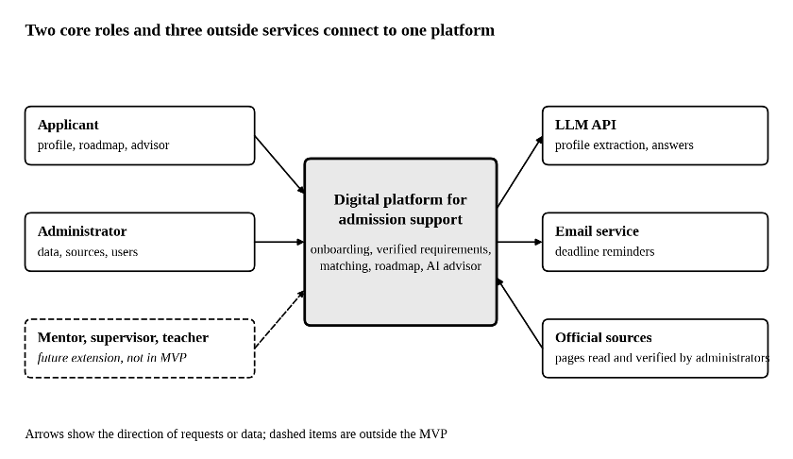
Figure 1. System context diagram

Description. Applicants and administrators use one platform, which calls an LLM API and an email service. Official sources are read and verified by administrators. Mentors, supervisors and teachers are dashed because they are a future extension.

7.3 Use case diagram
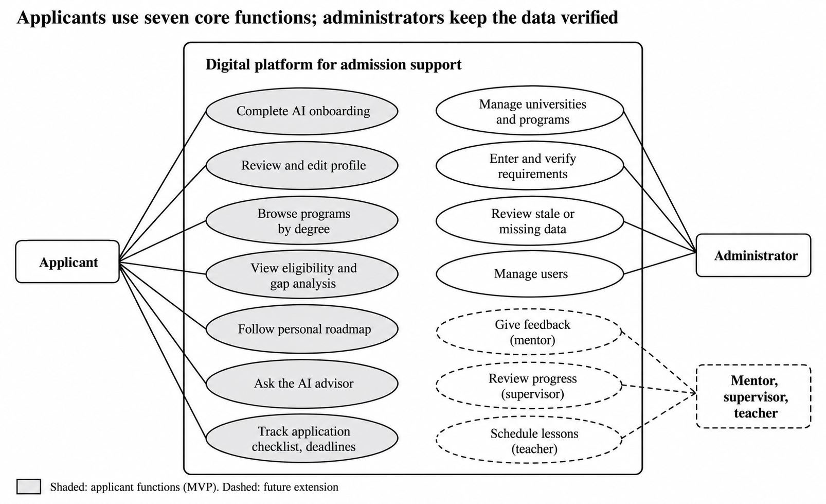
Figure 2. Use case diagram

Description. Seven applicant use cases form the core journey; four administrator use cases keep the data verified; future use cases are dashed.

7.4 Component diagram (draft)
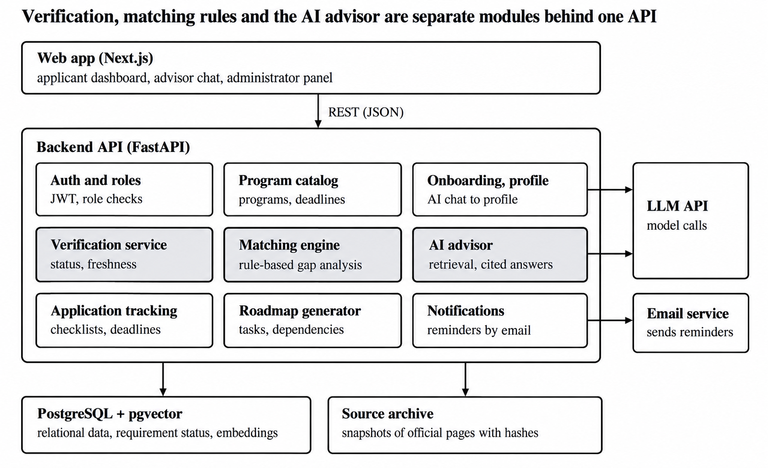
Figure 3. Component diagram (draft)
Description. The verification service, the matching engine and the AI advisor (shaded) are separate modules behind one REST API, so deterministic logic is isolated from the language model.

7.5 Entity relationship diagram
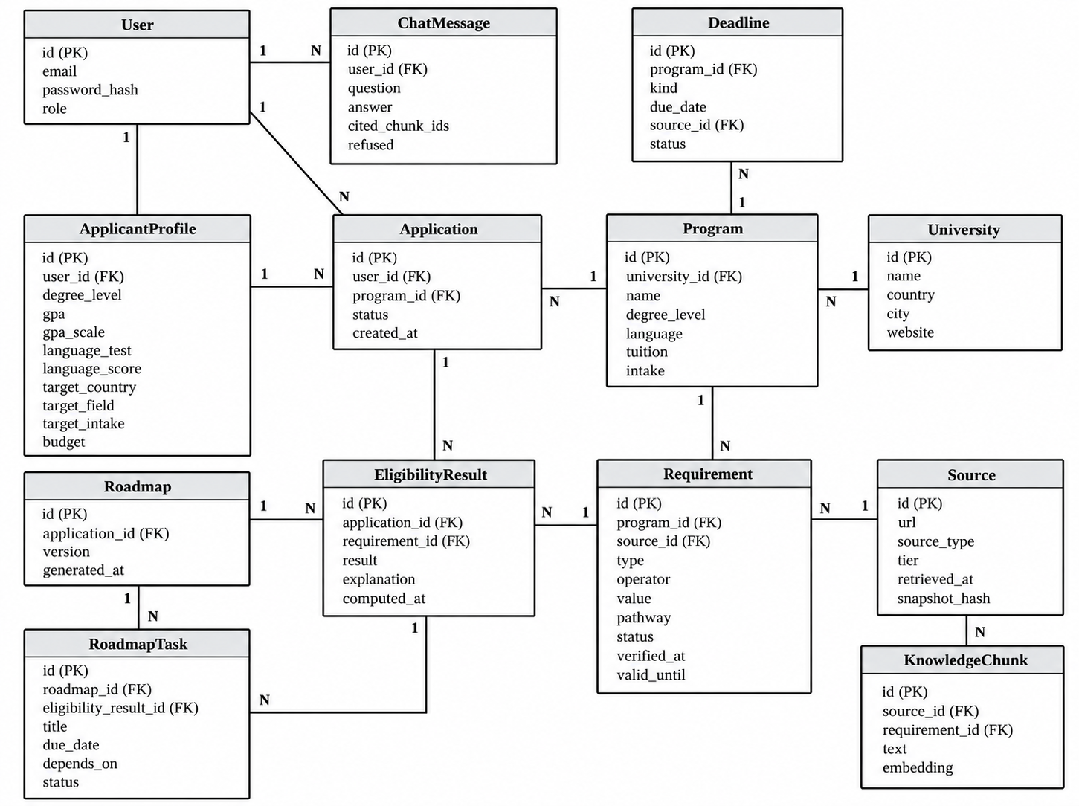
Figure 4. Entity relationship diagram ( draft)

Description. A program has requirements and deadlines, each pointing to its source; a requirement stores type, operator, value, pathway, status, verification date and validity date. An application links an applicant to a program and has eligibility results per requirement and a roadmap whose tasks reference the gaps. Knowledge chunks with embeddings support retrieval.

7.6 UML activity diagram
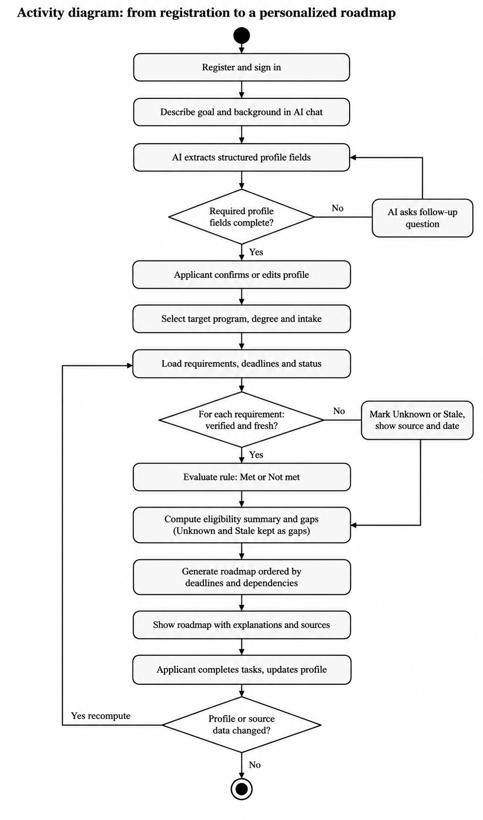
Figure 5. Activity diagram: registration to personalized roadmap

Description. After onboarding, the applicant selects a program; for each requirement the system checks whether it is verified and fresh, evaluates it as Met or Not met or marks it Unknown or Stale, converts gaps into an ordered roadmap and recomputes when the profile or data changes.

7.7 UML sequence diagram
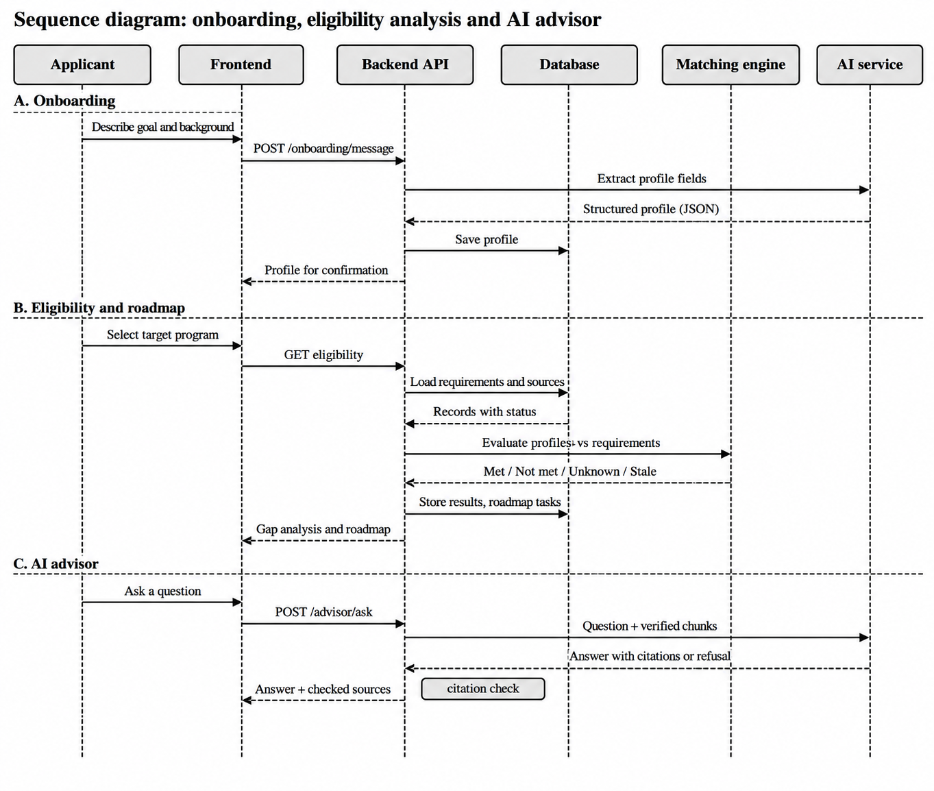
Figure 6. Sequence diagram: onboarding, eligibility analysis and AI advisor

Description. Phase A: profile extraction and storage. Phase B: loading requirements with status, matching, storing results and tasks. Phase C: retrieval, answer with citations or refusal, and a citation check before the answer is returned.

7.8 Alignment of requirements, components and data

Component | Requirements | Main entities
Auth and roles | FR-01, NFR-01 | User
Onboarding and Profile | FR-02, FR-03, NFR-02 | ApplicantProfile, ChatMessage
Program catalog | FR-04 | University, Program, Deadline
Verification service | FR-05, FR-06, FR-0, NFR-05 | Requirement, Source
Matching engine | FR-08, NFR-04 | EligibilityResult
Roadmap generator | FR-09 | Roadmap, RoadmapTask
AI advisor | FR-10, NFR-03 | KnowledgeChunk, ChatMessage
Application tracking, notification | FR-11, FR-12 | Application, Deadline

8. UX / prototype

8.1 Key scenarios

№ | Scenario | Steps | Requirements
S1 | A new applicant creates a profile | Sign in; describe background and goals in the AI chat; answer follow-up questions; check and edit the extracted profile | FR-01, FR-02, FR-03
S2 | An applicant checks eligibility and gets a roadmap | Choose a program; read requirements with status, source and date; read the eligibility summary; generate the roadmap and open the reason for each task | FR-04, FR-05, FR-08, FR-09
S3 | An applicant asks the advisor | Ask about a requirement; read the answer and its source; ask a question without a verified source and receive a refusal | FR-10, NFR-03

8.2 Mockups

The mockups use illustrative content. They show that status, source and date are always visible, that unknown or outdated information is never shown as met, and that every task has a reason.
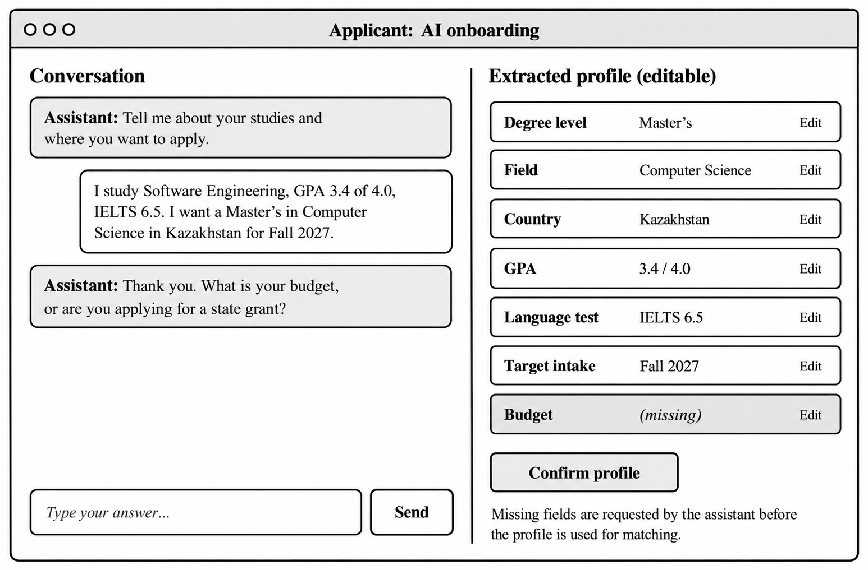

Figure 7. Mockup W1: AI onboarding (S1)

Description. The conversation on the left collects the profile; the extracted profile on the right is editable and the missing budget is requested before confirmation.
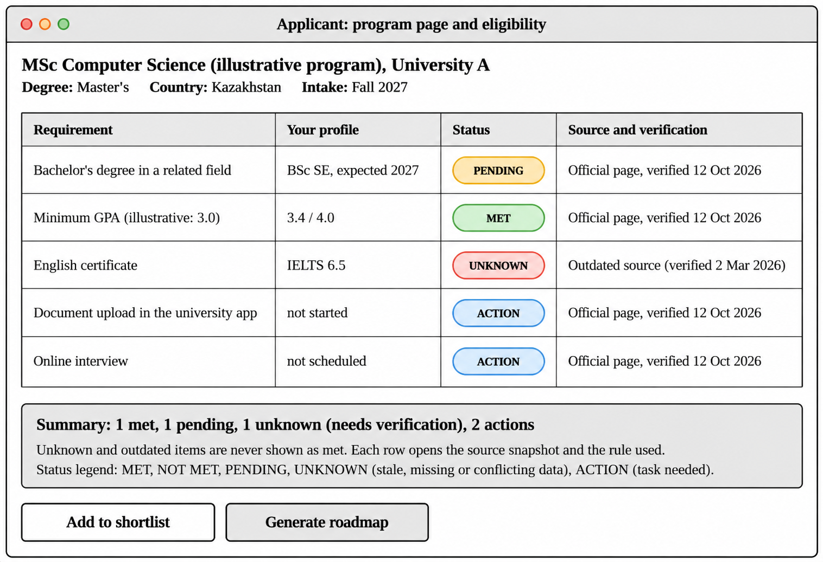Figure 8. Mockup W2: eligibility on the program page (S2)

Description. Each requirement shows the applicant’s value, a status badge and the source with verification date; the outdated source produces Unknown, not Met.
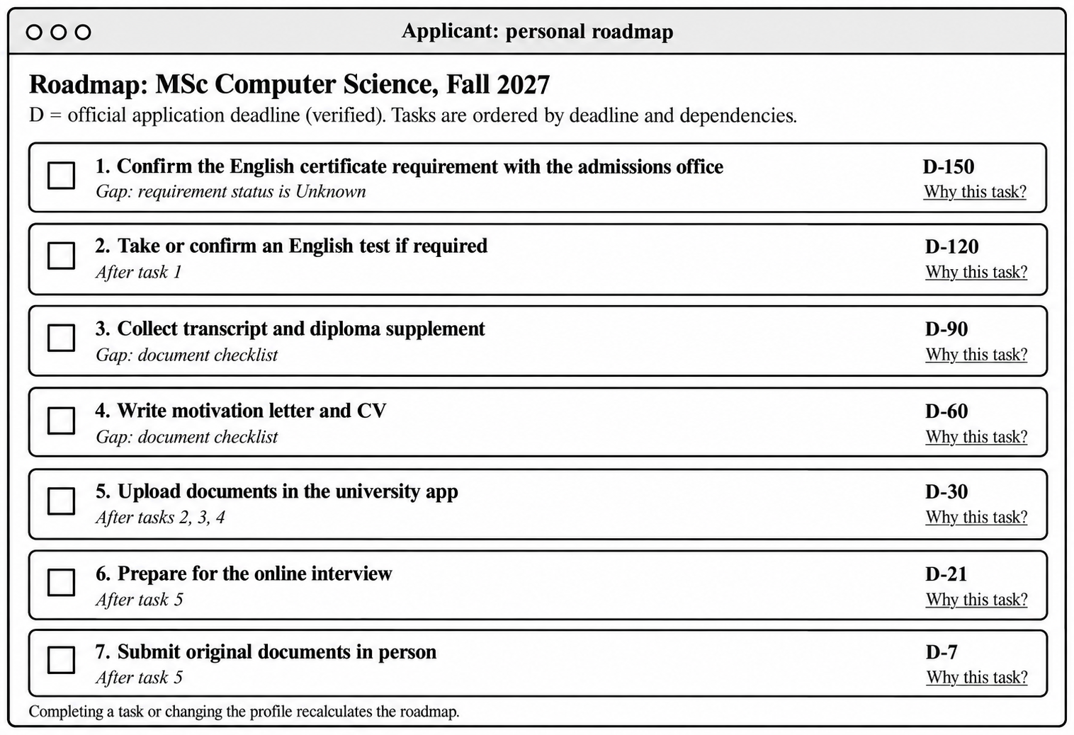

Figure 9. Mockup W3: personal roadmap (S2)

Description. Tasks are ordered by offsets from the verified deadline S and by dependencies; task shows the gap that caused it.

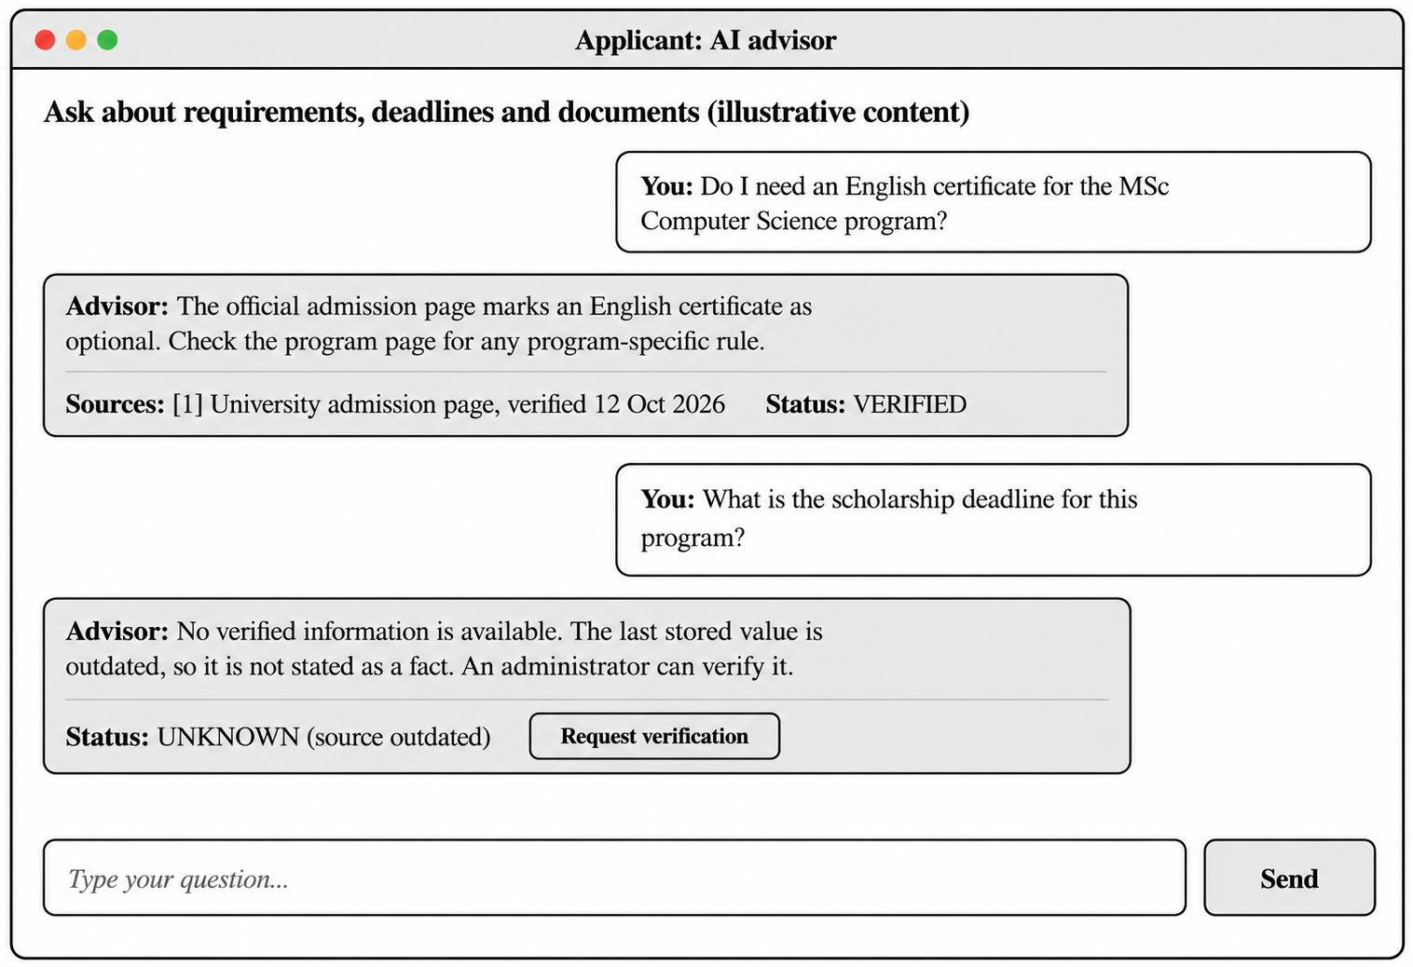Figure 10. Mockup W4: AI advisor (S3)

Description. The first answer cites a verified source with its date; the second question has no verified record, so the advisor refuses to state a fact and offers to request verification.

Prototype link:

9.Verification and evaluation plan

9.1 Baseline solutions

Component | Baseline for comparison
Recommendations and eligibility | B1: keyword filter by degree, country and field (a typical search portal); B2 manual determination by participants from official websites
Planning | B3: the traditional manual process using official websites without the platform
AI advisor | B4: the same LLM without retrieval; B5: retrieval without status filtering and citation validation

9.2 Evaluation questions, metrics and success criteria

ID | Questions and metrics | Metrics | Baseline | Success criterion
EQ1 | Are programme recommendations relevant? Evaluate recommendations using labelled applicant profiles. | Precision@5, Recall@5, nDCG@5 | B1, random order | Precision@5 ≥  80
EQ2 | Is eligibility matching correct? Test against manually verified admission requirements and edge cases. | Accuracy, macro-F1, false Met rate | Rule-based baseline | Accuracy ≥ 95%; false Met rate ≤ 2%; unverified data marked Unknown
EQ3 | Are roadmaps useful? Ask experts and applicants to evaluate task order and usefulness. | Expert rating, user agreement, next-action correctness | Manual roadmap | Mean expert rating ≥ 4/5; next-action correctness ≥ 80%
EQ4 | Does the platform improve the admission-planning process? Compare platform-assisted and manual planning. | Completion time, checklist completeness, error count | Manual planning | Reduced completion time and improved completeness
EQ5 | Are AI answers reliable and supported by sources? Test answerable, unanswerable, outdated and conflicting-data questions. | Answer correctness, citation precision, refusal accuracy | LLM without verified retrieval | Correctness ≥ 90%; refusal accuracy ≥ 90%; no unsupported deadlines presented as facts

9.3 Testing plan

Level | What is tested | Tool
Unit | Matching rules, status transitions, roadmap ordering | pytest
API and integration | Endpoints role permissions, database constraints | pytest with a test database
End-to-end | Scenarios S1 to S3 | Playwright
AI evaluation | The agreed AI evaluation set, citation validation, refusal behaviour | Scripted run, results logged
Security and usability | Access by the wrong role, secrets scan, five core tasks and SUS questionnaire | Checklist; observation

9.4 Measurement conditions

Evaluation uses a pilot dataset of verified programs (target: 20 programs across Bachelor’s, Master’s and PhD), synthetic applicant profiles for automated tests, and at least 8 volunteer participants for M4 to M6 who are not on the project team. Participants and results are recorded without storing personal data. Both team members run the same protocol, and results go into the repository’s evaluation folder.

10. Project management and risks

10.1 Repository and YouTrack

GitHub repository: https://github.com/Arthurmyn/unified-applicant-platform
YouTrack project: https://udp.youtrack.cloud/dashboard?id=177-0

10.2 Allocation of responsibilities and individual contributions
The project is developed by two team members with clearly defined responsibilities. Artur Jaxygaliyev is responsible for backend development, database design and API integration. Dinara Medeubek is responsible for machine learning, AI functionality and business analysis. Both members contribute to system design, testing and project documentation.

Area | Dinara Medeubek (ML, Business Analysis) | Arthur Jaxygaliyev (Backend, Frontend Development)
Frontend | Develop the AI onboarding chat and AI advisor interface, including displaying extracted profile data, answers and source references. | Develop the main layout, applicant dashboard, university and programme catalogue, eligibility results, roadmap, application checklist and administrator panel.
Backend | Define requirements for AI integration, profile extraction and retrieval. | Implement REST APIs, authentication, database operations, eligibility services and roadmap generation.
ML and AI | Implement AI onboarding, profile extraction, RAG-based answering, source-grounding and AI evaluation. | Integrate backend endpoints with the frontend and support AI-service integration.
Business Analysis | Analyse applicant needs, define user scenarios, functional requirements and evaluation criteria. | Analyze technical feasibility and document backend and interface requirements.
Testing and Documentation | Evaluate AI answers, extraction quality and source reliability; document the AI methodology. | Test frontend, APIs, database operations and integration; document architecture and implementation.

10.3 Milestones
Date | Milestone
12 to 16 Oct 2026 | Interviews held and logged
18 Oct 2026 | README, structure, YouTrack tasks and first merged pull requests exist
10-20 Oct 2026 | Prototype and diagram exports ready
Later phases | Core implementation and pilot dataset; evaluation studies; final report (dates to be fixed with the supervisor)

10.4 Risks and dependencies
Risk | Likelihood | Impact | Mitigation
Stored requirements are wrong or outdated | Medium | High | Status model, Tier 1 sources for Verified, cross-verification
The AI states a false deadline or rule | Medium | High | Retrieval only from Verified records, citation validation, refusal policy, 60- question evaluation
Scope too large for 2 people | High | High | Core scope only, supporting features is time allows
LLM cost, outage or model change | Medium | Medium | Provider-neutral interface, pinned model version
Uneven or untraceable contributions | Medium | High | Personal accounts, task-linked commits, cross-review, contribution log

Dependencies.The project depends on supervisor feedback, access to official university and scholarship information, an API key for the AI service, volunteers to test the platform, and a hosting service to demonstrate the system online.

11. Supervisor feedback
The supervisor, Altynbek Seitenov, assessed the proposal positively: the problem is relevant, the unified platform that supports applicants through admission is promising, and the combination of requirements, roadmaps, AI assistance and human support was appreciated. He approved the project for the first pre-defense.

ID | Recommendations | Decision and change | Where
R1 | Link the literature to the solution; state what is achieved, remaining limitations, influence on the design and difference from Common App and Studyportals; verify bibliographic details; separate integration from research contribution | Accepted. Structured analysis with methods and limitations, findings-to-design table, contributions C1 to C5, verified references | 3.2 to 3.6, 4
R2 | Clarify the final product and core functionality; separate core from secondary features; show the applicant journey | Accepted. Core, supporting, future and out-of-scope features; the journey is shown in scenarios and mockups | 1.6, 8
R3 | Add ERD, activity and sequence diagrams; explain verified, missing and outdated data | Accepted. Three new diagrams; five-state status model | 7.5 to 7.7, 6.3
R4 | Explain how effectiveness is measured | Accepted. Evaluation questions EQ1 to EQ5 with data, metrics, baselines and criteria | 9
R5 | State individual contributions and how they are demonstrated | Accepted. Responsibility table and evidence through GitHub, YouTrack and documentation | 10.2

